

**P.E.Society’s**

**MODERN COLLEGE OF**

**ARTS, SCIENCE & COMMERCE.**

**(Business Administration Campus),**

**SHIVAJI NAGAR, PUNE 411005.**

**SYNOPSIS**

**“Travel and Tour Management System”**

**Name: KRUNAL VIJAY DHANORKAR**

**Enroll - 8686**

**Class: TYBBA(CA**

**Division: B**

**Project Guide:**

**Prof. Gauri Khire Mam.**

**EXISTING SYSTEM** In the existing system, each task is carried out manually and processing is also a tedious job. In previous system travellers were maintaining time table details manually in pen and paper, which was time taking and costly. The traveller is not able to achieve its need in time and also the results may not accurate. Because of the manual maintenance there are number of difficulties and drawbacks exist in the system. Some of them are Drawbacks of the Existing System: • Increased transaction leads to increased source document and hence maintenance becomes difficult. • If any admin, user entry is wrongly made then the maintenance becomes very difficult. This system will work on online or as well as offline work.

**PROPOSED SYSTEM**

This system is design for the user to work easily and fastly on system by internet. This system is very helpful for the people to make their journey very easy and fastly. Also it is very useful for the owner of company and the hotel industry to grow their business. This system can save all the personal and important data with securely.

**Design Specification (DFD & ERD)**

**ERD:**

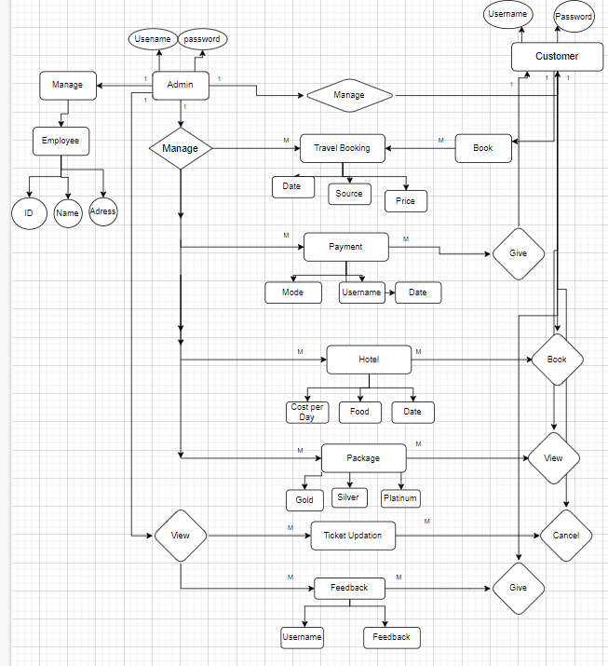

**DFD 0 –**

**Context DFD**

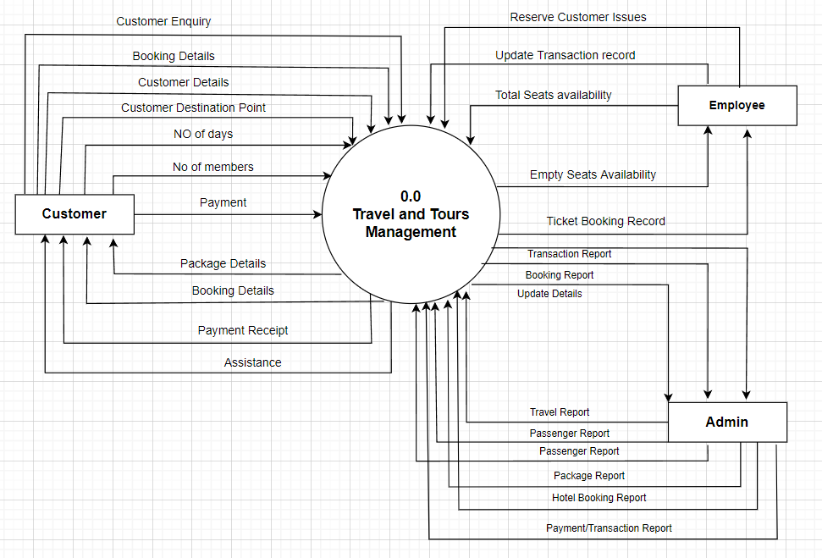

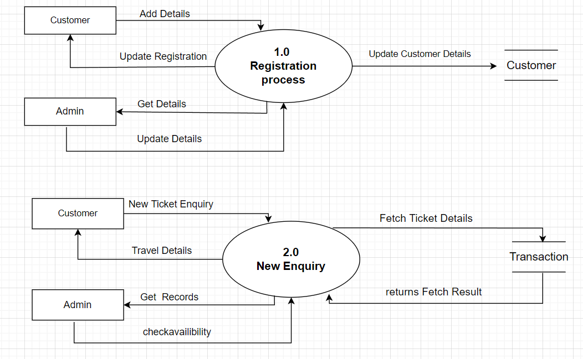

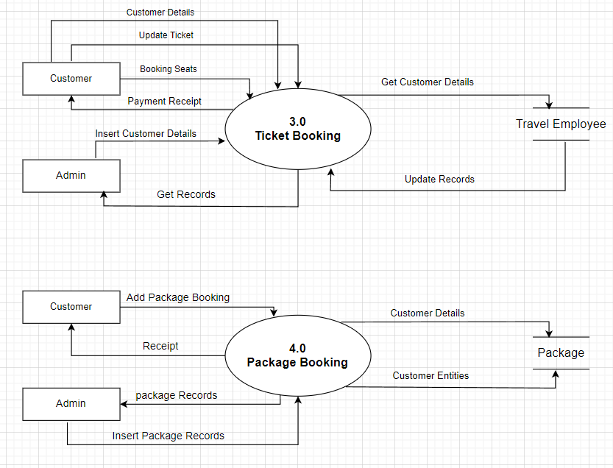

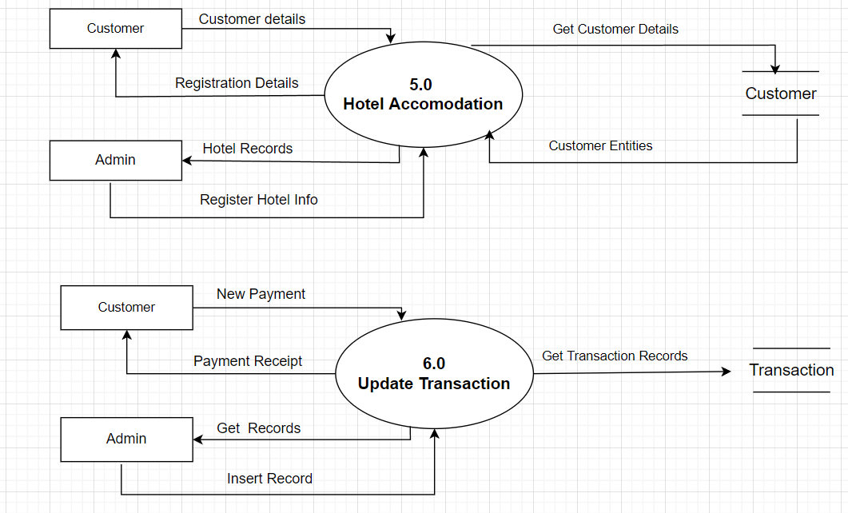

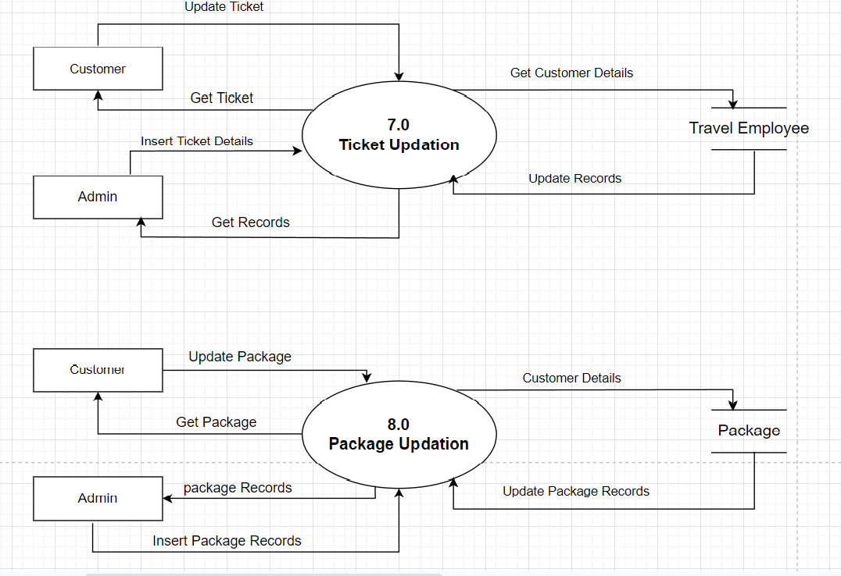

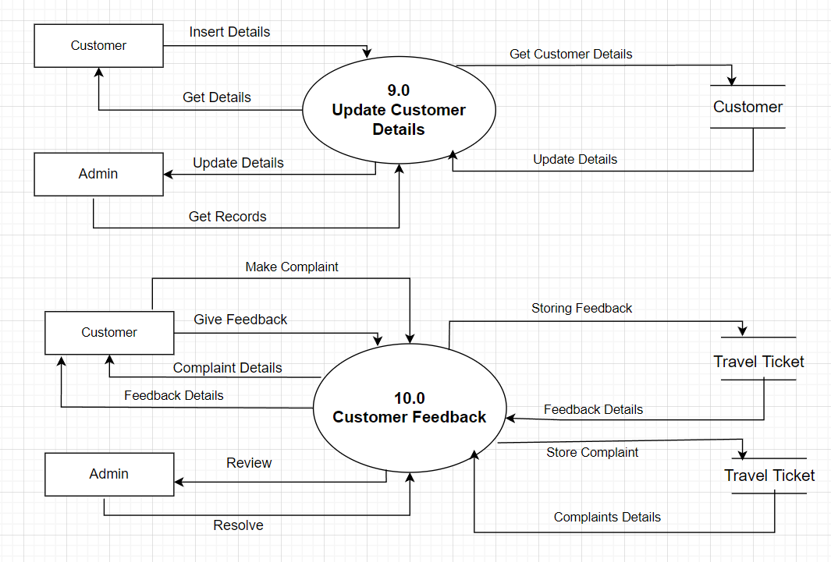

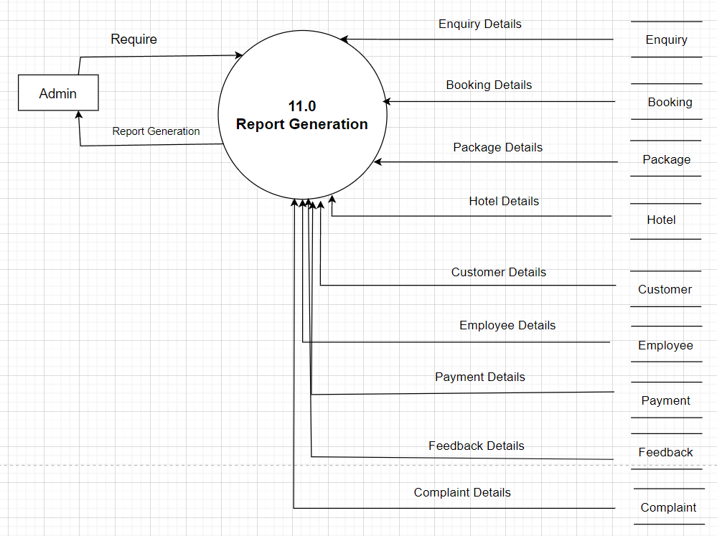

**FORM DESCRIPTION**

* **Customer Section**
* Login Form: Here agency employee login through given credentials like username and password which is provided by at the time of employee join the agency and done registration at office.
* Home Page: After employee login successful control goes to home page and at home page some menus are displayed.
* New Enquiry: In home page same menus are displayed in that new enquiry means when customer want to go anywhere that time he or she make an enquiry about tour packages and etc.
* Booking Form: In this field agency employee enters customer tour booking details.
* Package form: In this form the booking of travel packages by the user by selecting a various packages with date certain comments. 
* Hotel Booking Form: here customer can book the hotel .
* Feedback form: in this form customer can give feedback.
* About as form
* Contact us form

**Administration Section**

* Login Form: Here admin login through username and password which is provide at the time of software installation in his office.
* Home page form: After admin login successful control goes to home page and at home page some menus.
* Hotel form: in this form admin can add or update the information about the hotel .
* Employee Registration: Here admin should be entering employee’s details at the time of him or her join travel agency.
* Customer Report: In this field admin check daily customer’s report which is visit at travel agency office and enquiry for tour and booking the tickets.
* Booking Report: Here admin check the daily booking report related to tour booking like all consumers booking details.
* Package Form: Here to check the package master reports of tour generate when consumer select at time of booking.
* Transportation Report: In this section admin will check the transportation master report used for tour.
* Transaction Master: Here admin check and verify the daily as well as total transactions report of bookings.
* Feedbacks: This is module where passenger can post feedback after the journey and they can share their experience. Users of this application can post their opinions, complaints and suggestion regarding Photos, Videos.
* Tour Details: Details of different types of tours which include tours like family tours, couple tours, general tours, date and time of departure and the fair of the tours etc are maintained.

**FUTURE ENHANCEMENT**

This System being web-based and an undertaking of Cyber Security Division, needs to be thoroughly tested to find out any security gaps.

A console for the data center may be made available to allow the personnel to monitor on the sites which were cleared for hosting during a particular period. Moreover, it is just a beginning; further the system may be utilized in various other types of auditing operation viz. Network auditing or similar process/workflow based applications. Tourist can also get the Map and navigation system and temperature and weather information

**SOFTWARE REQUIREMENT**

**Front end:-Java**

**Back end:-MS Access 2008**

**HARDWARE REQUIREMENT**

**Processor: -** Intel core i7

**Operating System: -** Windows 7 or 10

**RAM: -** 4 GB

**Thank You!!!!!!!!!!!**